P.K.R ARTS & SCIENCE COLLEGE FOR WOMEN GOBICHETTIPALAYAM- 638 476
NAME  V.ABIRAMI | DESIGNATION  ASSISTANT PROFESSOR | 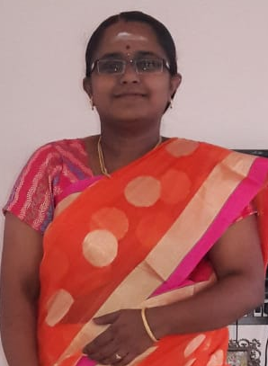
APPOINTMENT DATE  24.06.2013 | ADDRESS  98,BAJANAI KOVIL STREET PUDUPALAYAM GOBICHETTIPALAYAM-638 476

EDUCATIONAL QUALIFICATION

COURSE | MAJOR | BOARD/UNIV | SUBJECT | YEAR OF PASS
SSLC | -- | MATRIC | --- | 2004
HSC | Commerce with  CA | STATE BOARD | Commerce with CA | 2006
UG | BCOM[CA] | BHARATHIAR | Commerce with CA | 2009
PG | MCOM [CA] | BHARATHIAR | Commerce with CA | 2011
M.PHIL | COMMERCE | BHARATHIAR | Commerce | 2013
MBA | FINANCE | BHARATHIAR | FINANCE | 2015
AREA OF SPECIALISATION

FINANCE
TEACHING AND RESEARCH EXPERIENCE
COURSE | FROM | TO | TOTAL SERVICE
PG | 2015 | TILL DATE
UG | 2013 | TILL DATE

NUMBER OF M.Phil AND Ph.D PRODUCED
No.of M.Phil's Produced |  | No.of Ph.D's Produced
--- |  | ---

MEMBERSHIP IN COMMITTEES, ACADEMIC AND PROFESSIONAL BODIES (other
than our college)

NAME OF THE BODY/COMMITTEE | POSITION HELD | PERIOD

SEMINARS/CONFERENCES/WORKSHOPS ORGANISED

NO.OF ARTICLES / BOOKS PUBLISHED IN THE STATE, NATIONAL AND INTERNATIONAL LEVELS
PARTICULARS | STATE | NATIONAL | INTERNATIONAL | TOTAL
BOOKS | --- | --- | --- | ---
ARTICLES | --- | 1 | 3 | 4
ARTICLES IN  EDITED BOOK | --- | --- | --- | ---
SEMINAR  PROCEEDINGS | --- | --- | --- | ---
OTHERS | --- | --- | --- | ---

NO.OF SEMINARS, CONFERENCES,WORKSHOPS, ETC., PARTICIPATED, PAPERS PRESENTED AND POSITION HELD

COVERAGE | PARTICIPATION | PRESENTATION | RESOURCE PERSON | OTHERS
STATE LEVEL | --- | --- | --- | ---
NATIONAL  LEVEL | 10 | 10 | ---- | ---
INTERNATIONAL  LEVEL | 2 | 2 | -- | --

NO. OF ORIENTATION COURSES / REFRESHER COURSES PARTICIPATED

COURSE | NUMBER | YEAR/PERIOD | UNIVERSITY | YEAR/PERIOD
ORIENTATION | 1 | 2016 | BHARATHIAR UNIVERSITY | 10 DAYS
REFRESHER | ---

NUMBER OF RESEARCH PROJECTS UNDERTAKEN

Name of the Projects | Sponsoring Agency | Period | Amount

AWARDS / MEDALS / PRIZES RECEIVED

Particulars | Purpose | Agency | Year
AWARDS | ---
MEDALS | FIRST RANK IN M.COM (CA) | BHARATHIAR UNIVERSITY | 2011
PRIZES | ---
COMMENDATION | ---
OTHERS | ---

